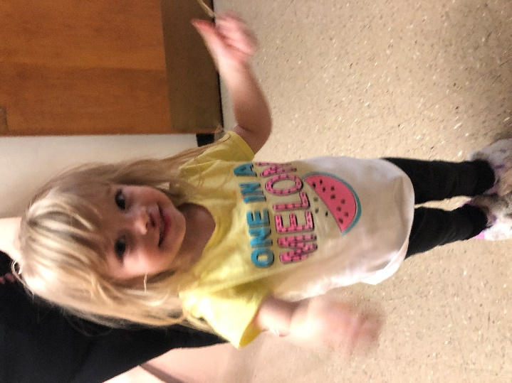
March 13, 2020
MIHN mom, Heather, got a new job! Way to go Heather!
Thank you to Kim Collier and her volunteers for organizing a birthday party for MIHN kid, Grace!
Thank you to We Are The World Day Camp for donating birthday boxes for our families!
We have raised over $4.1 million for our Capital Campaign! Only $1.1 million to go! The foundations have strongly encouraged us to reach out to individual donors and our congregations to donate to the campaign as well. If you, your congregation, or someone you know might be interested in donating, please contact Tom Miller at tmiller@familypromiseofmidland.com. Together we can make our vision come true!
**Our Day Center on 2908 W. Ohio has moved to 2301 Haynes Dr, Unit B. As we begin the construction for our Capital Campaign, we are using a vacant Families Forward Duplexes as our Day Center temporarily. Additionally, our Day Center phone number, (432) 218-7630, is out of service during the construction. If you have any questions, please call us at (432) 688-7710. We are excited for the future changes!**

Hosting
We, currently, have two families in the MIHN; two adults and three children, ages 7, 7, and 2.
Our families will move to True Lite Christian Fellowship this Sunday. Family Promise of Midland thanks Kim Collier and her volunteers for bringing meals this past week!
Thanks for all you do!
&
Have a joyful weekend!

