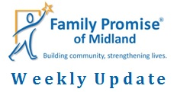
June 5, 2020
We’ve seen an increase in calls this week. We are expecting to bring more families into our programs in the next few weeks!
This week, Tom sat in on a Legal Aid of NorthWest Texas webinar. A MAJOR takeaway was that for any rental property that is Section 8 Housing OR the mortgage is backed by Federal Funds, there is a Federal moratorium on evictions until July 25th. The number of calls we receive will most likely increase after that date.
The MIHN has moved to a static sight due to COVID-19. This means that the families will spend the night at our Day Center instead of a host congregation. Hosting congregations will still bring nightly meals and provide groceries for the week. Our staff is working remotely, but you can still reach our staff by phone or email.
We have raised over $4.1 million for our Capital Campaign! Only $1.1 million to go! The foundations have strongly encouraged us to reach out to individual donors and our congregations to donate to the campaign as well. If you, your congregation, or someone you know might be interested in donating, please contact Tom Miller at tmiller@familypromiseofmidland.com. Together we can make our vision come true!
**Our Day Center on 2908 W. Ohio has moved to 2301 Haynes Dr, Unit B. As we begin the construction for our Capital Campaign, we are using a vacant Families Forward Duplexes as our Day Center temporarily. Additionally, our Day Center phone number, (432) 218-7630, is out of service during the construction. If you have any questions, please call us at (432) 688-7710. We are excited for the future changes!**

More Construction Photos!

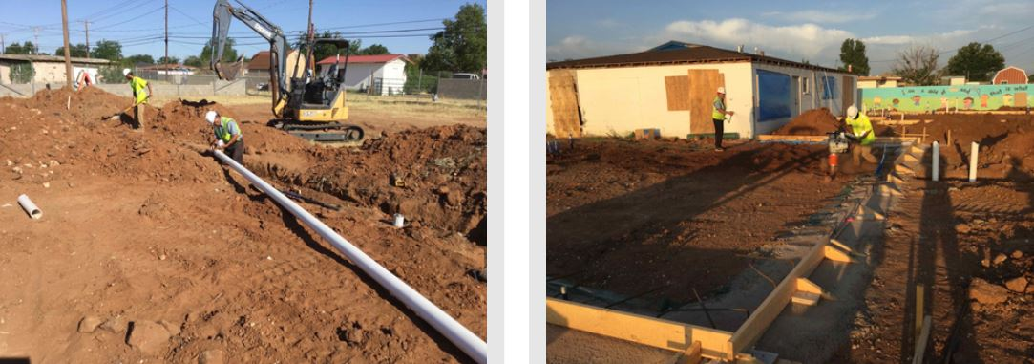

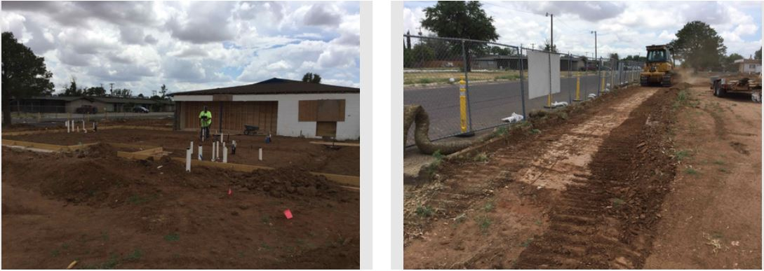

Hosting
We, currently, have one family in the MIHN; one adult and two children, ages 9 and 8.
Family Promise of Midland thanks Christian Church of Midland for bringing meals this past week.
Special thanks to Volunteer Coordinator, Cyndi!
Thanks for all you do!
&
Have a joyful weekend!

