[This Photo](http://www.pngall.com/december-png) by Unknown Author is licensed under [CC BY-NC](https://creativecommons.org/licenses/by-nc/3.0/)

**December 6, 2021**

Greetings All!

December is finally here, though we have yet to experience winter weather. I usually do not enjoy the cold, or snow but it just does not feel like December without those elements. During the month of December many of us have holiday traditions, some may go out and enjoy the Christmas lights or maybe go out caroling, one thing is for certain we all enjoy the holiday food and deserts. To get into the holiday spirit I am hoping that some of you would like to share some recipes, if you could kindly submit them by the 14th, I will add them on the 15th to our next Newsletter as well as share them with our families here at Family Promise. It is always fun to share and learn new recipes, you never know if it will turn into someone’s yearly tradition.

A friendly reminder:

By shopping on Amazon at “smile.amazon.com, Amazon will donate to your favorite charitable organization, at no cost to you! Amazon donates 0.5% of the price of eligible purchases! All you have to do to get started is copy the link below!

<https://smile.amazon.com/gp/chpf/homepage/ref=smi_chpf_redirect?ie=UTF8&ein=27-1003573&ref_=smi_ext_ch_27-1003573_cl>

Some good news to share, we are finally ordering furniture to add to the new units being built, it is making it that much more real on how soon we will be able to help more families overcome homelessness.



[This Photo](http://esheninger.blogspot.com/2017/03/get-good-news-out.html) by Unknown Author is licensed under [CC BY](https://creativecommons.org/licenses/by/3.0/)

***WARNING CUTENESS OVERLOAD****

Showing his new shoes! Sibling love.

Early Christmas gifts, with priceless smiles!

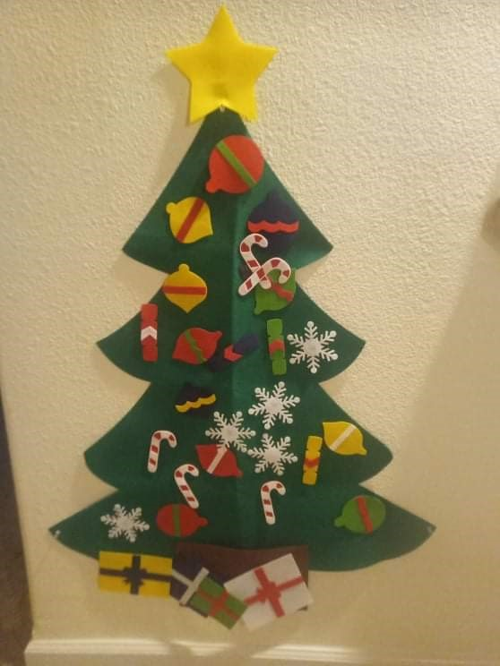 A family’s festive wall Christmas Tree.

Current count of Families

**MIHN Program**

Leavens Family 39F, 7M

Davis Family 22F, 1F

Rico Family 29F, 4F, 3F, 1F

Duplechin Family 45F, 17M, 15M

**FFTH Program**

Perez Family 37F, 6M

Soto Family 33F, 2M, 11mos F

\***Exited Families Forward** – Jones Family 29M, M6, F5, F4

Waiting List

Mendoza Family 34F, F7, 5F

Adams Family 37F, F11

Wilson Family 35F, F16, F6, 5F

I would like to share a letter from one of our families, just to show how Family Promise of Midland can make such a difference in people's lives.

Hello trisha,

What has Family Promise done for me. It has given me an opportunity to better myself as well as get back on my feet financially. Also gave me and my son a great place to live. They also help me mentally and emotionally. Providing parenting classes and everyday life classes. This journey that I'm taking with Family Promise has been great so far. I'm grateful for what they have done for my family, and I appreciate everything that has been provided for us. The classes that they provide for me; are essential for my wellbeing such as therapy, how to check your vehicle fluid and tires. How to save money and track my spending. Parent classes to interact with our children with education and supporting them. The home they provide for my family is great; it's just like an ordinary apartment. My child and I both have separate bedrooms and baths and a great kitchen and living room with washer and dryer. They also provide furniture for us. It also has a playground for my son. He loves it. Everything that I experienced with the program has been a blessing. I never thought I would ever get back on my feet. And for mental health to improve. It has given happiness and joy to have help when i nowhere to go.

Sincerely from, The Perez Family

**So again, from Family Promise of Midland we want to thank all of you for making a true difference in lives and none of this could had been possible without you.**

**\*\*\*We hope you have a happy and safe week\*\*\***